**40%**

**Using your textbook, labs and lecture notes to complete the following test in 3 hours or less.**

**All code submitted must be your original work. Code must be uploaded to GitHub in /HOT/CH6P2/ folder with the solution name HOT6P2 for grading.**

**EX1 ShirtSizes [50 pts]**

Create a program for ordering T-Shirts.

* Users can click a shirt size to add it to their order.
* Shirt prices are as shown. Tax is 7%.
* The user can remove all items from their order by clicking the "Clear Order" button.

**Screen Mockups**

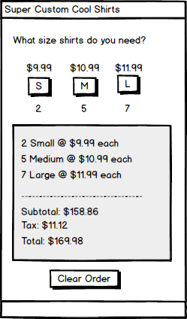

**Methods**

**AddShirt()** accepts a shirt size as a string and adds it to the user's order.

**ClearOrder()** removes all items from the user's order.

**ShowInvoice()** displays the invoice to user.

**EX2 ShirtDiscounts [50 pts]**

Create a program for ordering T-Shirts.

* Users must enter a quantity.
* Users can enter an optional discount code.
* Shirts are normally $13.75 each. Sales tax is 8%.
* If the discount code is valid, then apply the relevant discount.
* If the discount code is not valid, then do not apply a discount.

|  |  |
| --- | --- |
| **Discount Code** | **Discount Percentage** |
| 8264 | 30% off |
| 5679 | 20% off |
| 6483 | 10% off |

**Screen Mockups**

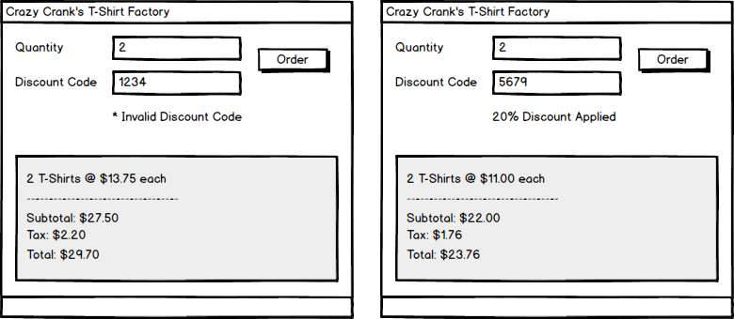

**Methods**

**CheckDiscountCode()** accepts a discount code as a string, returns the discount percentage as a float.

**ShowInvoice()** accepts the quantity as an int and the discount percentage as a float. Displays the invoice to user.

**Rubric EX1**

* Controls are laid out as expected – 5 pts
* Tab order is configured – 5 pts
* Control names follow naming conventions – 5 pts
* Variable names follow naming conventions – 5 pts
* UI implements all requested functionality - 6 pts
* **AddShirt()** functions and implemented as described - 8 pts
* **ClearOrder()** functions and implemented as described - 8 pts
* **ShowInvoice()** functions and implemented as described - 8 pts

**Rubric EX2**

* Controls are laid out as expected – 5 pts
* Tab order is configured – 5 pts
* Control names follow naming conventions – 5 pts
* Variable names follow naming conventions – 5 pts
* UI implements all requested functionality - 5 pts
* **CheckDiscountCode()** functions and implemented as described - 10 pts
* **CheckDiscountCode()** uses a loop to search and accurately validate the discount code - 5 pts
* **ShowInvoice()** functions and implemented as described - 10 pts